Project Proposal:

AWS Weather Monitoring

and Visualization System

AUTHOR: Cao Minh Nhat

HO CHI MINH CITY – 23rd July, 2025
WORD COUNT: 4600 EXCLUDING REFERENCES

Table of Contents
1. Executive Summary 3
2. Problem Statement 3
2.1. Difficulties in Data Collection 3
2.2. Challenges in Data Storage and Management 3
2.3. Lack of Visualization and Analysis Capabilities 3
2.4. Cost and Efficiency Issues 3
2.5. Security and Reliability Requirements 4
3. Solution Overview 4
3.1. Automated Data Collection 4
3.2. Flexible and Efficient Data Storage 4
3.3. Powerful and Interactive Data Visualization 4
3.4. Comprehensive Monitoring and Security 5
3.5. Scalability and Cost Optimization 5
4. Technical Architecture 5
4.1. Key Components 6
4.2. Data Flow 10
5. Business Analysis 11
5.1. Business Value Across Industries 11
5.2. Direct Benefits of the Solution 11
6. Cost-Benefit Analysis 12
6.1. Cost Analysis 12
6.2. Benefit Analysis 12
6.3. Return on Investment (ROI) 13
7. Implementation Plan 13
7.1. Phase 1: Basic Infrastructure Setup (Week 1 of the project) 13
7.2. Phase 2: Data Monitoring and Visualization (Week 2 of the project) 14
7.3. Phase 3: Optimization and Expansion (Week 3 onwards) 14
7.4. Estimated Timeline 15
8. Risk Management 16
8.1. Technical Risks 16
8.2. Operational Risks 17
8.3. Project Risks 18
9. Conclusion and Next Steps 18
9.1. Achieved Value 18
9.2. Future Enhancements 19
9.3. Call to Action 19
Appendices 19
A. Project Source Code 19
B. Cost Calculations 20
C. Architecture Diagrams 21
D. Lambda function code (function WeatherDataCollector): 21

1. Executive Summary
In today's digital age, data plays a pivotal role in making informed decisions. Particularly in the field of weather forecasting and monitoring, the efficient collection, processing, and visualization of data are crucial. This project proposes the development of a comprehensive AWS Weather Monitoring and Visualization System leveraging Amazon Web Services (AWS) cloud services. The primary objective is to automate the process of collecting weather data from public APIs, securely storing it, and providing powerful visualization capabilities through interactive dashboards. The system is designed to be cost-effective, highly scalable, and secure, making it suitable for applications ranging from meteorological research to data-driven business decision support. This solution not only addresses the need for up-to-date weather data but also provides a flexible platform for deeper analysis and understanding of climatic trends, thereby offering significant benefits to users and organizations. This project will serve as a clear demonstration of applying modern cloud technologies to solve real-world problems, while showcasing skills in architectural design, software development, and project management within the AWS environment.

2. Problem Statement
In various sectors, from agriculture, logistics, and tourism to disaster risk management, accurate and timely weather data is a critical factor. However, collecting and utilizing weather data often faces several significant challenges:

2.1. Difficulties in Data Collection
Weather data sources are often scattered and come in various formats. Accessing and aggregating data from public weather APIs requires significant technical knowledge and effort. These APIs may have access frequency limitations, complex authentication requirements, or return inconsistent data, making it difficult to automate the collection process.

2.2. Challenges in Data Storage and Management
As weather data is continuously collected over time, the volume of data can grow rapidly. Storing this data efficiently, securely, and with quick retrieval capabilities is a challenge. Traditional storage solutions may not meet the scalability and durability requirements necessary for large time-series data.

2.3. Lack of Visualization and Analysis Capabilities
Even when data has been collected and stored, transforming raw data into valuable and understandable information is another challenge. Traditional analysis and visualization tools often require specialized skills in data analysis or programming. The lack of interactive dashboards and real-time data filtering capabilities reduces the ability of end-users to make timely decisions based on weather data.

2.4. Cost and Efficiency Issues
Building and maintaining an infrastructure to collect, process, and visualize weather data can be costly, especially if not optimized. On-premise solutions require significant investment in hardware, maintenance, and personnel. Even in the cloud, selecting and configuring inappropriate services can lead to unnecessary costs and poor performance.

2.5. Security and Reliability Requirements
Weather data, while not as sensitive as personal data, still needs to be protected from unauthorized access and ensure its integrity. The system must be fault-tolerant and continuously operational to provide reliable data. The lack of proper security measures and monitoring can lead to data breaches, service interruptions, or other security vulnerabilities.
To address these issues, this project proposes a solution based on the AWS Cloud, leveraging managed services to provide an automated, efficient, secure, and cost-effective system for collecting, storing, processing, and visualizing weather data.

3. Solution Overview
To address the identified problems, we propose a solution based on a serverless architecture and managed AWS services. This solution focuses on automating the entire process from data collection to visualization, ensuring efficiency, scalability, reliability, and security.

3.1. Automated Data Collection
The solution utilizes AWS Lambda to automate weather data collection. A Lambda function will be triggered periodically (e.g., every 5 minutes, hourly) by Amazon EventBridge (formerly CloudWatch Events). This function will call public weather APIs (e.g., Open-Meteo API) to retrieve current weather data for predefined locations. Using Lambda eliminates the need for server management, automatically scales with demand, and charges only for execution time, optimizing costs.

3.2. Flexible and Efficient Data Storage
Collected weather data will be stored in two primary AWS services for different purposes:
- Amazon DynamoDB: A fast, flexible, and highly scalable NoSQL database used to store near real-time weather data. DynamoDB provides consistent performance at any scale, ideal for applications requiring quick data access, such as a React Dashboard. It is well-suited for time-series data.
- Amazon S3 (Simple Storage Service): Raw and processed data will be stored as JSON or CSV files in S3. S3 is a highly durable, virtually limitless, and low-cost object storage service. S3 will serve as an intermediate data lake for analytics and visualization tools like AWS QuickSight, as well as for historical data analysis or future machine learning purposes.

3.3. Powerful and Interactive Data Visualization
The solution offers two visualization options to meet different needs:
- AWS QuickSight: A cloud-native Business Intelligence (BI) service that allows the creation of interactive dashboards and reports from data in S3. QuickSight provides powerful, easy-to-use analytics capabilities and can be widely shared. It is an ideal choice for historical data analysis and trend visualization.
- React-based Web Dashboard: A frontend web application built with React, capable of embedding QuickSight dashboards and providing custom time filters (e.g., 1 hour, 2 days, 1 week, 1 month). This dashboard will offer a user-friendly interface, allowing end-users to easily access and interact with real-time weather data. This application can be hosted on Amazon S3 as a static website and distributed via Amazon CloudFront to ensure fast access and security.

3.4. Comprehensive Monitoring and Security
- Amazon CloudWatch: Used to monitor the performance and health of the entire system. CloudWatch will collect metrics from Lambda, DynamoDB, S3, and other services. Alarms will be set up to notify immediately of any issues (e.g., Lambda errors, DynamoDB throttling).
- AWS Identity and Access Management (IAM): Ensures system security by applying the Principle of Least Privilege. IAM Roles will be configured to grant specific access permissions to each service, mitigating security risks.
- Data Encryption: Data will be encrypted both at rest (in DynamoDB and S3) and in transit (via HTTPS/SSL/TLS), ensuring data confidentiality and integrity.

3.5. Scalability and Cost Optimization
The serverless architecture of the solution ensures automatic scalability with demand, thereby optimizing costs. You only pay for the resources you consume, eliminating the need for upfront provisioning or over-investment in infrastructure. This makes the solution highly cost-effective, especially for projects with fluctuating workloads.
Overall, this solution provides a robust, reliable, secure, and cost-effective system for weather data monitoring and visualization, fully meeting the requirements of a practical and professional project.

4. Technical Architecture
The architecture of the weather data monitoring and visualization system is designed based on the principles of serverless architecture, scalability, high durability, and security. The diagram below illustrates the data flow and interaction between the main AWS services:
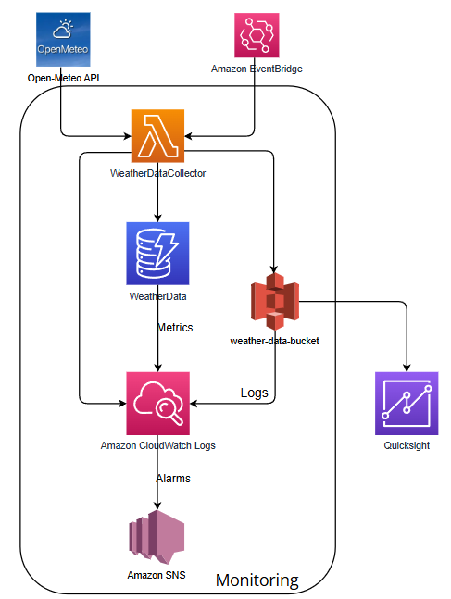

4.1. Key Components

4.4.1. Open-Meteo API
- Role: Open-Meteo is the primary source of weather data. Chosen for its simplicity, free usage, and no API key requirement for basic use cases, making it suitable for demo and learning purposes. This API provides current and forecast weather data for various geographical locations.
- Interaction: The AWS Lambda function will send HTTP GET requests to this API to retrieve weather data in JSON format.

4.1.2. AWS Lambda (WeatherDataCollector)

- Role: The heart of the data collection system. This is a serverless function that executes Python code to call the Open-Meteo API, process the received data, and store it in AWS storage services.
- Trigger: Activated periodically by Amazon EventBridge (CloudWatch Events) on a defined schedule (e.g., every 5 minutes, hourly).
- Functionality:
Sends HTTP requests to the Open-Meteo API with parameters for latitude, longitude, and required weather metrics.
Parses the JSON response from the API.
Stores the collected weather data in Amazon DynamoDB.
Stores the weather data in Amazon S3 as JSON or CSV files for QuickSight and long-term storage.
- Advantages: No server management required, automatic scaling, pay only for execution time.

4.1.3. Amazon EventBridge (CloudWatch Events)

- Role: A scheduling service that triggers the WeatherDataCollector Lambda function at a specific frequency. It acts as a timer, ensuring data is collected regularly and automatically.
- Configuration: A rule is created to define the schedule (e.g., cron(0/5 * * * ? *) for every 5 minutes) and the target is the WeatherDataCollector Lambda function.

4.1.4. Amazon DynamoDB (WeatherData Table)
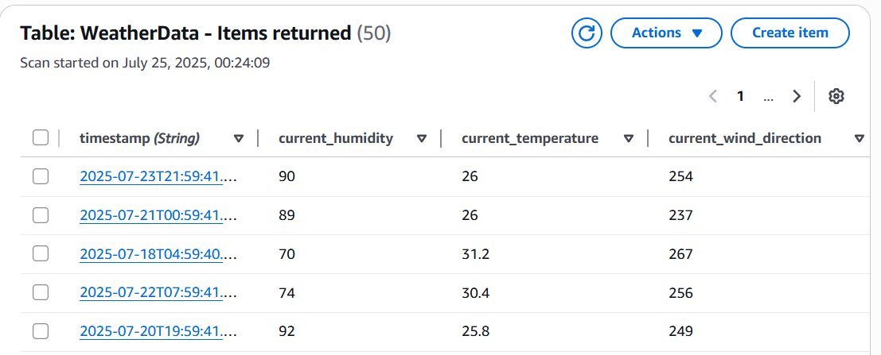
- Role: A fully managed NoSQL database used to store near real-time weather data. DynamoDB provides high performance and low latency, ideal for applications requiring fast data access, such as the React dashboard.
- Structure: The WeatherData table will have location (e.g., latitude,longitude) as the Partition Key and timestamp as the Sort Key, allowing efficient queries by location and time.
- Encryption: Data is encrypted at rest by default using AWS KMS.

4.1.5. Amazon S3 (weather-data-bucket-saigon)
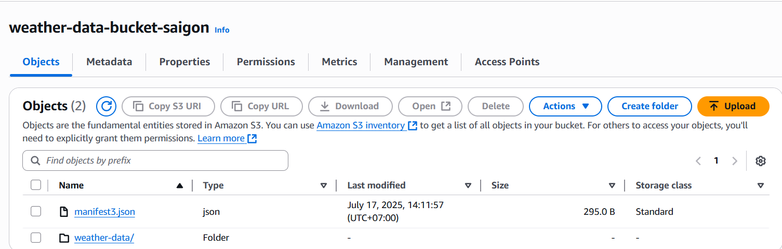
- Role: A highly durable and virtually limitless object storage service. S3 is used to store raw and processed weather data as JSON or CSV files. It serves as the primary data lake for historical analysis and as the data source for AWS QuickSight.
- Structure: there will be a manifest file and then a folder weather-data/ holding all the single data file each draw each hour
- Encryption: Data is encrypted at rest using Server-Side Encryption (SSE-S3).

4.1.6. AWS QuickSight
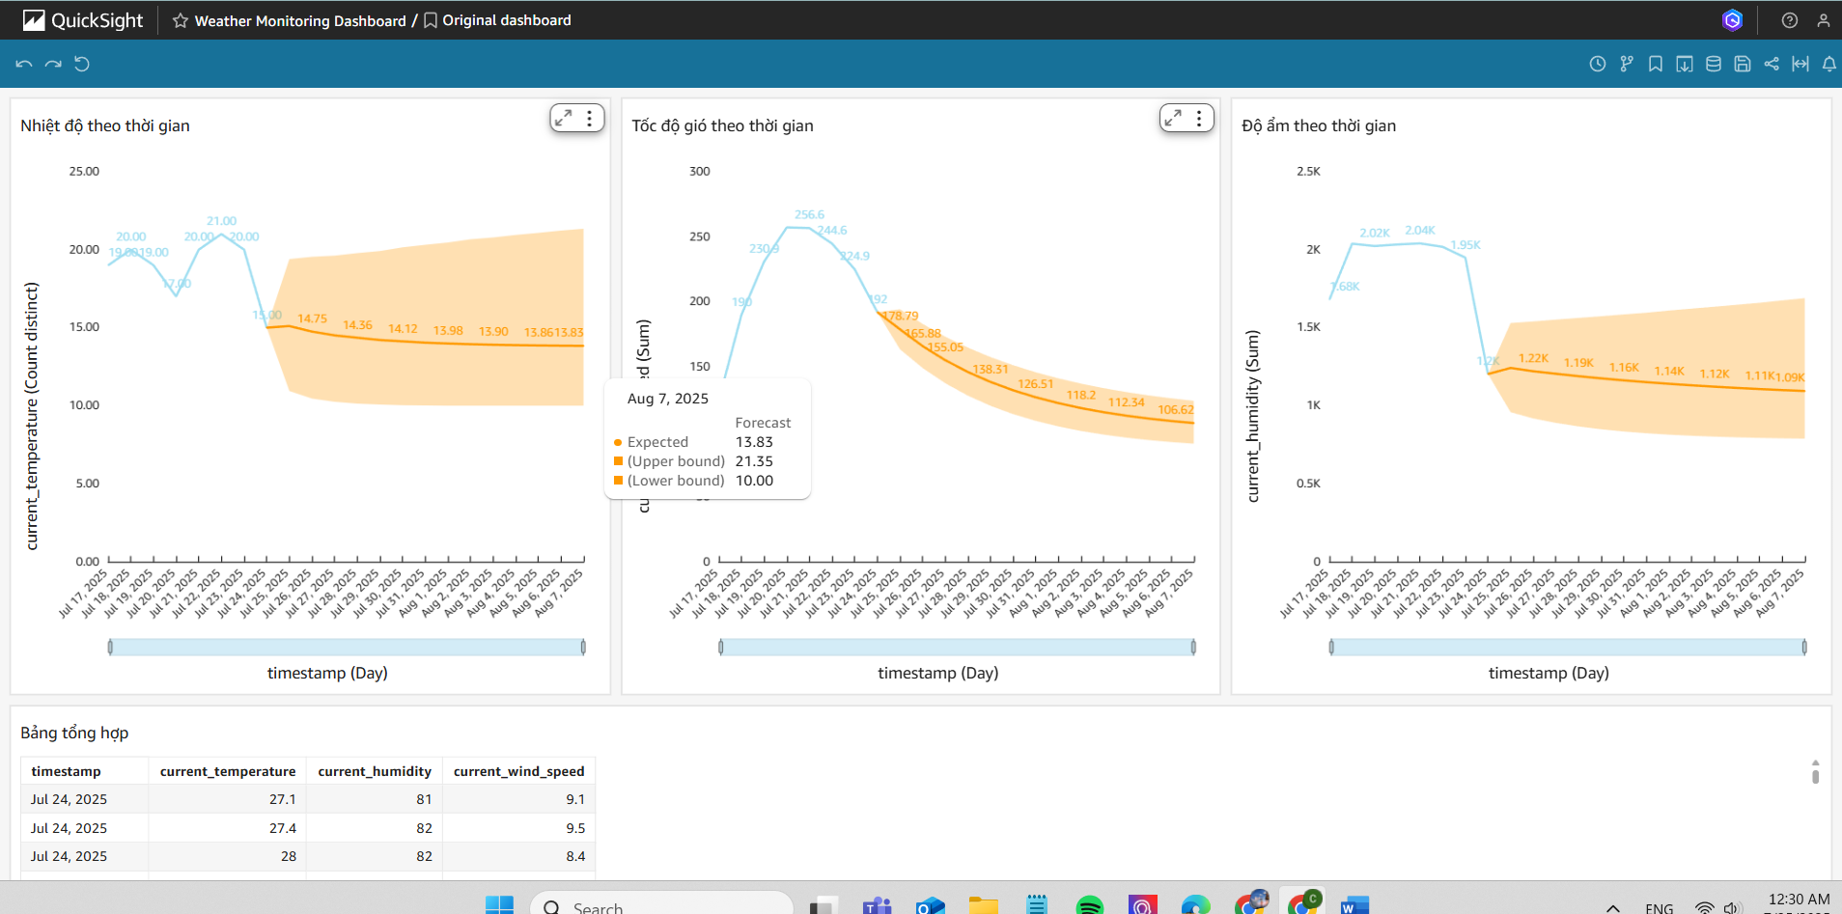
- Role: A cloud-based Business Intelligence (BI) service used to create interactive dashboards and reports from data stored in S3. QuickSight allows users to explore data, create charts, and visualize weather trends.
- Data Source: Connects directly to the S3 bucket (weather-data-bucket) to read CSV files containing weather data.
- Features: Supports filters, drill-downs, and the ability to share dashboards publicly or embed them into other web applications.

4.1.7. Amazon CloudWatch (Logs, Metrics, Alarms, Dashboards)
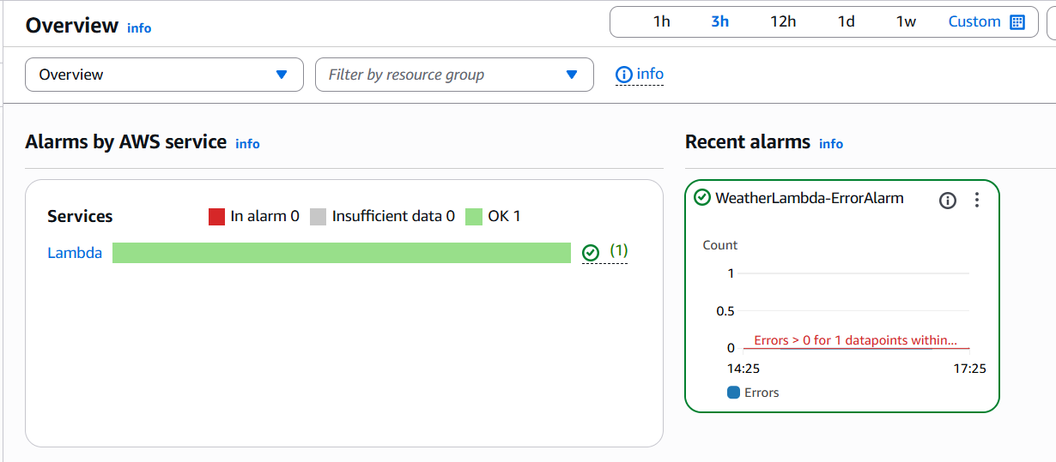
- Role: A centralized monitoring and management service. CloudWatch collects logs from Lambda and other services (CloudWatch Logs), gathers performance and error metrics (CloudWatch Metrics), allows setting up alerts (CloudWatch Alarms), and creates visual dashboards (CloudWatch Dashboards).
- Functionality:
Logs: Records all activities and errors of the Lambda function, aiding in debugging and auditing.
Metrics: Monitors Lambda function invocations, execution time, errors, DynamoDB throttled requests, etc.
Alarms: Sends notifications via Amazon SNS when defined thresholds are exceeded (e.g., Lambda errors > 0, DynamoDB ThrottledRequests > 0).
Dashboards: Provides an overview of the health and performance of the entire system.

4.1.8. Amazon SNS (Simple Notification Service)

- Role: A fully managed messaging service used to send notifications from CloudWatch Alarms to subscribers (e.g., email, SMS).
- Interaction: CloudWatch Alarms publish messages to an SNS Topic, and subscribers to that topic receive notifications.

4.1.9. AWS IAM (Identity and Access Management)
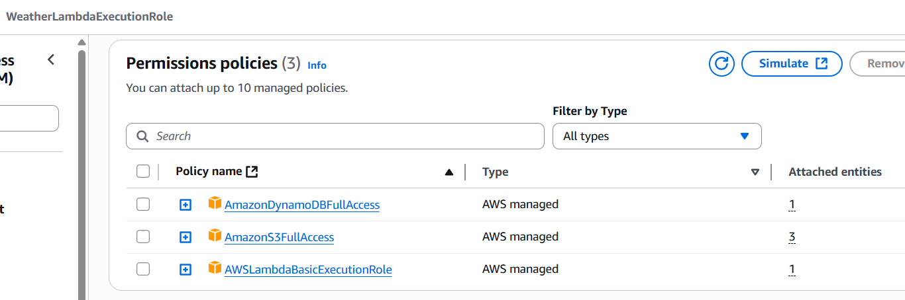
- Role: An identity and access management service that allows you to securely control access to AWS resources. IAM ensures that only authorized users or services can perform specific actions on specific resources.
- Functionality:
Creates IAM Roles for the Lambda function to grant access to DynamoDB, S3, and CloudWatch Logs.
Applies the Principle of Least Privilege by using specific custom policies, granting only necessary permissions (e.g., dynamodb:PutItem, s3:PutObject).

4.2. Data Flow
- Trigger: Amazon EventBridge triggers the AWS Lambda WeatherDataCollector function on schedule.
- Collection: The Lambda function calls the Open-Meteo API to retrieve weather data.
- Storage:
Data is stored in Amazon DynamoDB (for fast access).
Data is also stored in Amazon S3 as files (for analysis and long-term storage).
- Monitoring: All activities and errors are logged in Amazon CloudWatch Logs, and metrics are sent to CloudWatch Metrics.
- Alerting: CloudWatch Alarms monitor metrics and send notifications via Amazon SNS if issues occur.
- Visualization (QuickSight): AWS QuickSight reads data from S3 to create and display analytical dashboards.
This architecture provides a robust, flexible, and cost-effective solution for weather data monitoring and visualization, while adhering to AWS security and scalability principles.

5. Business Analysis
The AWS Weather Monitoring and Visualization System project is not merely a technical solution but also brings significant business value to organizations and individuals across various sectors. Having accurate, timely, and accessible weather data can directly impact operational efficiency, decision-making capabilities, and competitive advantage.

5.1. Business Value Across Industries
- Optimized Production: Farmers can use temperature, humidity, and rainfall data to determine optimal times for planting, irrigation, fertilization, and harvesting. This helps minimize crop loss risks due to adverse weather conditions and increases crop yields.
- Risk Management: Weather forecasts help farmers prepare for extreme events such as droughts, floods, or frosts, thereby minimizing damage to crops and livestock.
- Route Optimization: Transportation companies can use weather data to plan more efficient routes, avoiding areas with severe weather (storms, heavy snow, fog), which helps reduce transit times, save fuel, and enhance safety.
- Supply Chain Management: Weather forecasts impact on-time delivery, especially for temperature-sensitive goods or those requiring specific storage conditions.
- Activity Planning: Event organizers, resorts, and amusement parks can use weather data to plan and adjust outdoor activities, ensuring the best experience for customers.
- Safety: Warnings about hazardous weather help protect tourists and staff during activities like hiking, beach visits, or large events.
- Demand Forecasting: Energy companies can forecast electricity demand based on temperature, helping to optimize power generation and distribution.
- Renewable Energy: For solar and wind energy, weather data is a crucial factor for forecasting power output, thereby managing the grid more effectively.
- Disaster Prevention: Urban management agencies can use weather data to issue early warnings about floods, storms, or other extreme weather events, helping to evacuate residents and protect infrastructure in a timely manner.
- Water Resource Management: Rainfall data helps manage reservoirs, dams, and drainage systems efficiently.

5.2. Direct Benefits of the Solution
- Accurate and Timely Data: The system automatically collects data from reliable sources, ensuring information is always up-to-date.
- Improved Decision-Making: Interactive and intuitive dashboards help users easily understand data, leading to faster and more accurate decisions.
- Operational Optimization: Reduces risks, saves costs, and increases efficiency in weather-dependent operations.
- Scalability: The serverless architecture on AWS allows the system to easily scale to collect data from more locations or monitor more metrics without significant infrastructure changes.
- Cost-Effectiveness: AWS's pay-as-you-go model helps control costs, especially suitable for startups or projects with limited budgets.
- Security and Reliability: Integrated security measures and continuous monitoring ensure data protection and stable system operation.
This solution not only provides a weather monitoring tool but also a powerful data platform, opening up many opportunities for in-depth analysis and the development of value-added applications in the future.

6. Cost-Benefit Analysis
A cost-benefit analysis is crucial for evaluating the feasibility and value of a project. We will consider both the implementation and operational costs, as well as the tangible and intangible benefits that the project brings.

6.1. Cost Analysis
The serverless architecture of the project significantly optimizes costs. Most of the services used are covered by the AWS Free Tier, allowing the project to operate at very low or near-zero cost in the initial phase.
Service | Usage (Estimated) | Cost (Estimated/month)
AWS Lambda | 100,000 requests/month, 128MB RAM, 1s/request | ~$0.02
Amazon DynamoDB | 1GB storage, 25 WCU, 25 RCU | ~$0.25
Amazon S3 | 5GB storage, 20,000 GET, 2,000 PUT | ~$0.12
Amazon EventBridge | 1 million events/month | ~$1.00
AWS QuickSight | 1 Author (Standard Edition) | $9.00
Amazon CloudWatch | 5GB logs, 10 alarms, 1M API requests | ~$2.50
Total |  | ~$12.89/month
Note: The costs above are estimates and may vary depending on actual usage. In the initial phase, with the AWS Free Tier, costs can be virtually zero.
- Personnel: The main cost is the time and effort of the development team. This project is designed to be completed by one developer in approximately 1-2 weeks.
- Tools: Utilizes open-source and free tools (Visual Studio Code, Git, Node.js, Python), incurring no software costs.

6.2. Benefit Analysis
- Operational Cost Savings: Automating data collection reduces manual effort, saving time and personnel costs.
- Risk and Damage Reduction: In industries like agriculture and logistics, accurate weather data can help minimize damage due to adverse weather, providing direct economic benefits.
- Increased Production Efficiency: Optimizing production, transportation, or other schedules based on weather data can lead to increased productivity and revenue.
- Improved Decision-Making: Provides timely and intuitive information, helping managers make better, faster decisions.
- Enhanced Safety: Early warnings about hazardous weather help protect people and assets.
- Increased Customer Satisfaction: In the tourism and service industries, providing accurate weather information and appropriate planning enhances customer experience.
- Competitive Advantage: Organizations capable of leveraging weather data will have a competitive edge over rivals who cannot.
- Platform for Innovation: This system can serve as a foundation for developing other value-added applications in the future, such as machine learning-based forecasting models.

6.3. Return on Investment (ROI)
With very low operational costs (under $20/month) and the potential for significant economic benefits through operational optimization and risk reduction, the ROI of this project is expected to be very high. Especially in the context of an internship project, the greatest value lies in learning and applying modern cloud technologies, building a complete and professional product, thereby enhancing capabilities and career opportunities in the future.

7. Implementation Plan
The implementation plan for the AWS Weather Monitoring and Visualization System project is divided into clear phases, ensuring sequential, efficient, and manageable execution. Each phase includes specific tasks, required resources, and expected deliverables.

7.1. Phase 1: Basic Infrastructure Setup (Week 1 of the project)
Objective: Establish the foundational AWS infrastructure and core data collection components.
Tasks:
- AWS Account Setup: Ensure an AWS account is created and configured with necessary access permissions (IAM User/Role).
- Create IAM Roles and Policies: Create IAM Roles and Custom Policies with the principle of least privilege for Lambda, DynamoDB, S3, and CloudWatch. (e.g., WeatherDataCollectorPolicy for Lambda).
- Create DynamoDB Table: Create the WeatherData table in DynamoDB with appropriate Partition Key and Sort Key (location, timestamp). Ensure encryption at rest is enabled.
- Create S3 Bucket: Create the weather-data-bucket S3 bucket for storing raw and processed data. Enable Server-Side Encryption (SSE-S3).
- Develop Lambda Function (WeatherDataCollector): Write Python code for the Lambda function to:
Call the Open-Meteo API.
Process the JSON response.
Store data in DynamoDB.
Store data in S3 as JSON/CSV files.
- Call the Open-Meteo API.
- Process the JSON response.
- Store data in DynamoDB.
- Store data in S3 as JSON/CSV files.
- Configure EventBridge Rule: Create an EventBridge Rule to trigger the WeatherDataCollector Lambda function on a schedule (e.g., every 5 minutes).
Deliverables:
- Basic AWS infrastructure established.
- Lambda function operational, automatically collecting and storing data in DynamoDB and S3.
- Weather data begins accumulating in storage services.

7.2. Phase 2: Data Monitoring and Visualization (Week 2 of the project)
Objective: Deploy monitoring tools and build data visualization dashboards.
Tasks:
- Configure CloudWatch Logs: Ensure the Lambda function logs to CloudWatch Logs. Configure retention policies and encryption for log groups.
- Set up CloudWatch Alarms: Create critical alarms for:
Lambda errors (Errors > 0).
DynamoDB throttling (ThrottledRequests > 0).
Configure notifications via Amazon SNS (email).
- Lambda errors (Errors > 0).
- DynamoDB throttling (ThrottledRequests > 0).
- Configure notifications via Amazon SNS (email).
- Build AWS QuickSight Dashboard:
Create a dataset in QuickSight from the S3 bucket (weather-data-bucket).
Design charts and visuals to display weather data (temperature, humidity, wind speed, etc.).
Configure time range filters in QuickSight.
Publish the dashboard and enable embedding (public or secure).
Deliverables:
- Monitoring system operational, sending alerts on issues.
- QuickSight dashboard displaying weather data, accessible for analysis and interaction.

7.3. Phase 3: Optimization and Expansion (Week 3 onwards)
Objective: Improve performance, optimize costs, enhance security, and expand features.
Tasks:
- Cost Optimization:
Regularly review AWS costs using AWS Cost Explorer.
Adjust DynamoDB RCU/WCU or configure Auto Scaling.
Optimize Lambda configuration (RAM, timeout).
Apply S3 Lifecycle Policies to transition older data to cheaper storage tiers (e.g., S3 Glacier).
- Regularly review AWS costs using AWS Cost Explorer.
- Adjust DynamoDB RCU/WCU or configure Auto Scaling.
- Optimize Lambda configuration (RAM, timeout).
- Apply S3 Lifecycle Policies to transition older data to cheaper storage tiers (e.g., S3 Glacier).
- Security Enhancement:
Re-evaluate IAM Policies to ensure adherence to the Principle of Least Privilege.
Implement AWS Secrets Manager or Parameter Store for API key management (if applicable).
Consider placing Lambda in a VPC if private resource access is required.
Deliverables:
- System operates stably, cost-effectively, and securely.
- New features implemented, enhancing the system's value.
- Project ready for future development and expansion.

7.4. Estimated Timeline
Phase | Estimated Time | Key Tasks | Deliverables | Responsibility | Notes
1. Basic Infrastructure | 1 Week | AWS setup, Lambda, DynamoDB, S3, EventBridge development | Automated data collection | Cloud/DevOps Engineer | Can leverage AWS Free Tier
2. Monitoring & Visualization | 1 Week | CloudWatch configuration, QuickSight Dashboard, React Web Dashboard build | Operational dashboard, full monitoring | Data/Frontend Engineer | Requires data accumulated from Phase 1
3. Optimization & Expansion | Ongoing | Cost optimization, security, feature expansion | Complete system, added value | Cloud/DevOps Engineer | Based on feedback and needs
This plan provides a clear roadmap for project implementation, ensuring that objectives are met systematically and efficiently.

8. Risk Management
In any project, identifying, assessing, and planning responses to risks are crucial for ensuring project success. Below are the potential risks and mitigation strategies for the AWS Weather Monitoring and Visualization System project.

8.1. Technical Risks

8.1.1. Risk: Unstable or Changing Weather API
- Description: The Open-Meteo API may experience outages, changes in response structure, or impose stricter usage limits in the future, affecting data collection capabilities.
- Mitigation Strategies:
Diversify API Sources: Research and prepare alternative weather APIs (e.g., WeatherAPI, OpenWeatherMap) to enable quick switching if needed.
API Monitoring: Use CloudWatch to monitor errors and response times of the Lambda function when calling external APIs. Set up alerts if the error rate increases significantly.
Robust Error Handling: Implement retry mechanisms and exponential backoff in the Lambda function when calling external APIs to handle transient errors.

8.1.2. Risk: Errors in Lambda Data Processing

- Description: The Lambda function may encounter errors during JSON data parsing, format conversion, or data writing to DynamoDB/S3.
- Mitigation Strategies:
Unit Testing: Write unit tests for the data processing logic within the Lambda function.
Dead Letter Queue (DLQ): Configure a DLQ (e.g., an SQS queue) for the Lambda function to send failed events for later analysis and reprocessing.
Detailed Logging: Log all processing steps and critical data values to CloudWatch Logs for easy debugging.

8.1.3. Risk: Insufficient DynamoDB/S3 Performance

- Description: If data volume spikes or DynamoDB capacity configuration is insufficient, throttling may occur, or S3 may experience issues with write/read speeds.
- Mitigation Strategies:
Auto Scaling: Enable Auto Scaling for DynamoDB to automatically adjust Read/Write Capacity Units (RCU/WCU) based on load.
CloudWatch Monitoring: Set up CloudWatch alarms for DynamoDB ThrottledRequests and S3 performance metrics.
Data Structure Optimization: Ensure DynamoDB Partition Key and Sort Key are well-designed for even load distribution.

8.1.4. Risk: QuickSight Dashboard Display Issues or Slowness

- Description: QuickSight may have issues connecting to S3, data may not be updated promptly, or the dashboard may be too complex, leading to slow loading times.
- Mitigation Strategies:
Data Source Validation: Ensure QuickSight's IAM Role has sufficient permissions to access the S3 bucket and that the CSV/JSON file structure in S3 is valid.
SPICE Capacity: Increase SPICE capacity in QuickSight if needed to improve query performance.
Dashboard Optimization: Limit the number of visuals and complex calculations on the dashboard to ensure fast loading.

8.2. Operational Risks

8.2.1. Risk: Exceeding AWS Cost Projections
- Description: Although the serverless architecture optimizes costs, inefficient usage or a sudden increase in data volume could lead to higher-than-expected costs.
- Mitigation Strategies:
Set Budgets: Use AWS Budgets to set up alerts when costs exceed a certain threshold.
Resource Optimization: Periodically review and optimize Lambda configuration (RAM, execution time), DynamoDB (RCU/WCU), and S3 (lifecycle policies).
Free Tier: Maximize the use of AWS Free Tier during development and testing phases.

8.2.2. Risk: Security Vulnerabilities
- Description: Vulnerabilities in IAM configuration, sensitive information leakage (API keys), or unauthorized data access.
- Mitigation Strategies:
Principle of Least Privilege: Always apply the principle of least privilege to all IAM Roles and Policies.
Secrets Management: Use AWS Secrets Manager or AWS Systems Manager Parameter Store (SecureString) to store and manage API keys.
Encryption: Ensure data is encrypted both at rest and in transit.
Regular Security Audits: Use AWS Security Hub or other security auditing tools to detect vulnerabilities.

8.3. Project Risks

8.3.1. Risk: Lack of Time or Resources
- Description: The project may not be completed on time due to lack of time, skills, or resources.
- Mitigation Strategies:
Clear Scope: Keep the project scope focused on the most essential and core features.
Detailed Planning: Break down the project into smaller, manageable phases and tasks.
Leverage Documentation: Utilize the detailed guides provided to accelerate deployment.

8.3.2. Risk: Lack of AWS Experience

- Description: If the implementer has limited AWS experience, they may face difficulties in configuration or debugging.
- Mitigation Strategies:
Detailed Guides: Provide comprehensive, step-by-step documentation.
Support: Be available to provide support and answer questions during implementation.
Hands-on Practice: Encourage hands-on practice on the AWS Free Tier to familiarize with services.
By proactively identifying and planning responses to these risks, we can minimize negative impacts and increase the likelihood of project success.

9. Conclusion and Next Steps
The AWS-based Weather Monitoring and Visualization System project has demonstrated the ability to build a comprehensive, efficient, and reliable solution for collecting, storing, and visualizing weather data. By leveraging the power of serverless architecture and managed AWS services such as Lambda, DynamoDB, S3, QuickSight, and CloudWatch, we have created a highly scalable, cost-effective, and easily maintainable system.
This solution not only addresses current challenges in weather data collection and analysis but also opens up numerous new opportunities for future applications. From supporting decision-making in agriculture and logistics to providing critical information for tourism and urban management, accurate and timely weather data is an invaluable asset.

9.1. Achieved Value
- Full Automation: Eliminates manual intervention in the data collection process.
- Cost-Effectiveness: Optimizes operational costs through AWS's pay-as-you-go model and leveraging the Free Tier.
- High Scalability and Durability: The system can handle large volumes of data and ensures high availability.
- Powerful Visualization: Provides interactive and easy-to-understand dashboards, helping users quickly grasp information.
- Security and Monitoring: Ensures data security and early detection of issues.

9.2. Future Enhancements
To further enhance the value of the system, we propose several next steps for development:
- Integrate More APIs: Connect with other weather APIs (e.g., WeatherAPI, AccuWeather) to obtain more diverse data and increase redundancy.
- Collect More Metrics: Extend to collect more specialized weather metrics such as UV index, air quality, pollen count, etc.
- Machine Learning: Apply Machine Learning models (e.g., using Amazon SageMaker) to build custom weather forecasting models, detect anomalies, or predict extreme weather events.
- Historical Data Analysis: Develop more in-depth analytical tools on historical data in S3 to discover long-term trends and correlations.
- Customizable Dashboard: Allow end-users to customize widgets and dashboard layouts according to their personal needs.
- Personalized Notifications: Develop a feature to send personalized weather notifications (e.g., via email, SMS) based on user preferences or location.
- Mobile Application: Build a mobile application for users to access weather data anytime, anywhere.
- API Gateway: Build an API Gateway to expose processed weather data to other applications or systems.
- IoT Integration: Connect with IoT devices (e.g., local weather sensors) to collect hyper-local and real-time data.

9.3. Call to Action
This project provides a solid foundation for weather data management. With the proposed next steps, the system will become an even more powerful tool, bringing immense value to any organization looking to leverage the power of weather data. We believe that investing in this solution will yield significant returns on investment and contribute to overall success.

Appendices
The following documents and source code provide detailed information and support for the AWS Weather Monitoring and Visualization System project.

A. Project Source Code
GitHub Repository: https://github.com/NhatCao0/Internship.git
Contains the source code for the AWS Lambda function, DynamoDB configuration, S3, and the React Web Dashboard.

B. Cost Calculations
The estimated cost each month is as below:
Service | Usage (Estimated) | Cost (Estimated/month)
AWS Lambda | 100,000 requests/month, 128MB RAM, 1s/request | ~$0.02
Amazon DynamoDB | 1GB storage, 25 WCU, 25 RCU | ~$0.25
Amazon S3 | 5GB storage, 20,000 GET, 2,000 PUT | ~$0.12
Amazon EventBridge | 1 million events/month | ~$1.00
AWS QuickSight | 1 Author (Standard Edition) | $9.00
Amazon CloudWatch | 5GB logs, 10 alarms, 1M API requests | ~$2.50
Total |  | ~$12.89/month

C. Architecture Diagrams


D. Lambda function code (function WeatherDataCollector):
import json
import boto3
from datetime import datetime
from urllib import request, parse
from decimal import Decimal
import logging

logger = logging.getLogger()
logger.setLevel(logging.INFO)

dynamodb = boto3.resource('dynamodb')
table = dynamodb.Table('WeatherData')

s3 = boto3.client('s3')
bucket_name = 'weather-data-bucket-saigon'

# Custom JSON encoder
class DecimalEncoder(json.JSONEncoder):
def default(self, obj):
if isinstance(obj, Decimal):
return float(obj)
return super(DecimalEncoder, self).default(obj)

def lambda_handler(event, context):
try:
latitude = 10.7769
longitude = 106.7009

api_url = "https://api.open-meteo.com/v1/forecast"
params = {
'latitude': latitude,
'longitude': longitude,
'current': 'temperature_2m,relative_humidity_2m,wind_speed_10m,wind_direction_10m,weather_code',
'timezone': 'Asia/Bangkok',
'forecast_days': 1
}

query_string = parse.urlencode(params)
full_url = f"{api_url}?{query_string}"

logger.info(f"Calling Open-Meteo API for coordinates: {latitude}, {longitude}")
with request.urlopen(full_url, timeout=10) as resp:
weather_data = json.loads(resp.read().decode())

current_data = weather_data.get('current')
if not current_data:
raise ValueError("No 'current' data returned from API")

def to_decimal(val):
return Decimal(str(val)) if val is not None else None

timestamp = datetime.utcnow().isoformat()

item = {
'location': f"{latitude},{longitude}",
'timestamp': timestamp,
'current_temperature': to_decimal(current_data.get('temperature_2m')),
'current_humidity': to_decimal(current_data.get('relative_humidity_2m')),
'current_wind_speed': to_decimal(current_data.get('wind_speed_10m')),
'current_wind_direction': to_decimal(current_data.get('wind_direction_10m')),
'weather_code': int(current_data.get('weather_code')) if current_data.get('weather_code') is not None else None,
'data_source': 'open-meteo'
}

logger.info(f"Saving weather data to DynamoDB: {item}")
table.put_item(Item=item)

# Save to S3
s3_key = f"weather-data/{timestamp}.json"
s3.put_object(
Bucket=bucket_name,
Key=s3_key,
Body=json.dumps(item, cls=DecimalEncoder),
ContentType='application/json'
)

return {
'statusCode': 200,
'body': json.dumps({
'message': 'Weather data collected successfully',
'timestamp': timestamp,
'temperature': item['current_temperature'],
'humidity': item['current_humidity'],
'wind_speed': item['current_wind_speed']
}, cls=DecimalEncoder)
}

except Exception as e:
logger.error(f"Error: {str(e)}")
return {
'statusCode': 500,
'body': json.dumps({
'error': str(e)
})
}

